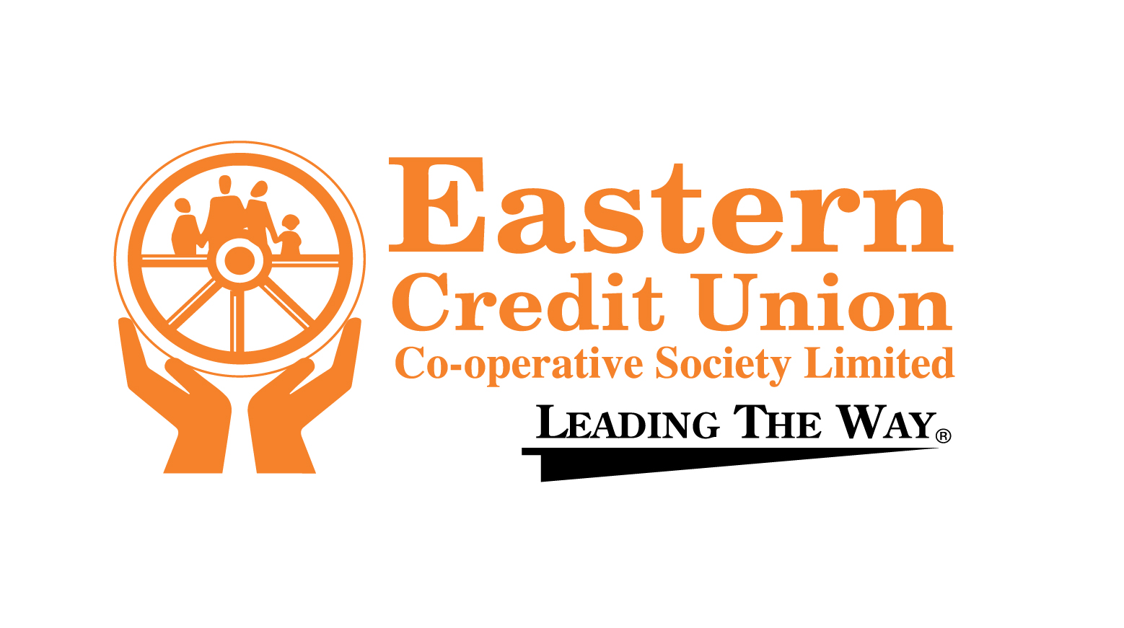

Basis of Nomination:
- Merit – Student with grades over 80%
- Needs- Statement of need to be provided.

ALL REQUESTED INFORMATION MUST BE COMPLETED FOR APPLICATION FORM TO BE ELIGIBLE.

Student’s Name: __________________________ Tel# ______________
Student SEA #______________Eastern Credit Union Account#: ________________
Student’s Address: ________________________________________
Name of School: _________________________________________
Total household monthly income: ________________________________
Total household monthly expenses: _______________________________
Number of dependents (children under 18 years of age) ______________________

Parent/Guardian’s Name: ___________________________Tel. #_______________
Email: _______________________Eastern Credit Union Account#: ______________

EXAMINATION RESULTS:

EXAM CATERGORY | SCORE ATTAINED
Composite Score
National Percentile Ranking
Gender Percentile Ranking
Creative Writing
Mathematics
Language Arts

A COPY OF THE STANDARD COMPOSITE SCORE SHEET FROM THE MINISTRY OF EDUCATION MUST BE ATTACHED FOR VERIFICATION OF RESULTS
NB: The Student or the Parent / Guardian must be a member of Eastern Credit Union in good standing.
DEADLINE FOR SUBMISSION OF APPLICATIONS: 19th July 2024.

